**The Erechtheion**

* Built between the Old Temple of Athena (destroyed by Persians) and the cliff
* Ionic temple (contrast to Parthenon which is Doric)
  + Columns more slender
  + More decorative detail

**Eastern Part**

* Temple dedicated to Athena
* “Temple to Athena Polias”
* East Side Columns
  + Glass inlaid
  + Gold around the bases
  + Grows slightly more slender as it nears the top

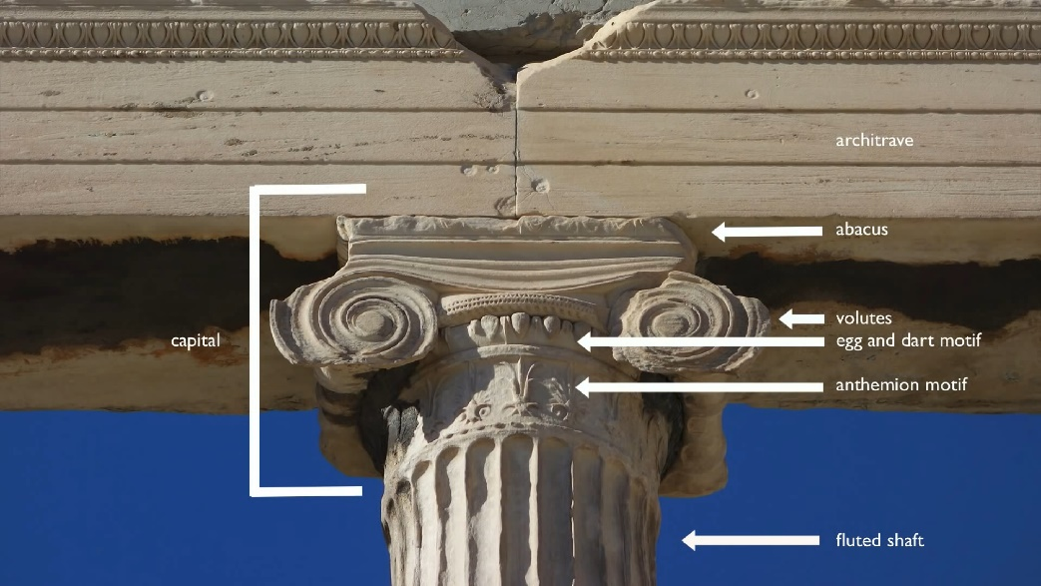

* East Room
  + Held Olivewood statue of Athena said to be dropped from the heavens; very simple statue in contrast with the Athena Parthenos

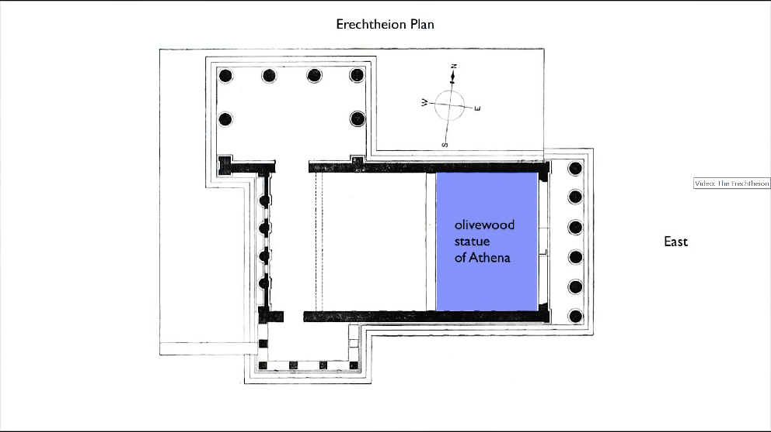

* Entering from the east side…
  + Walk into shallow cella
  + 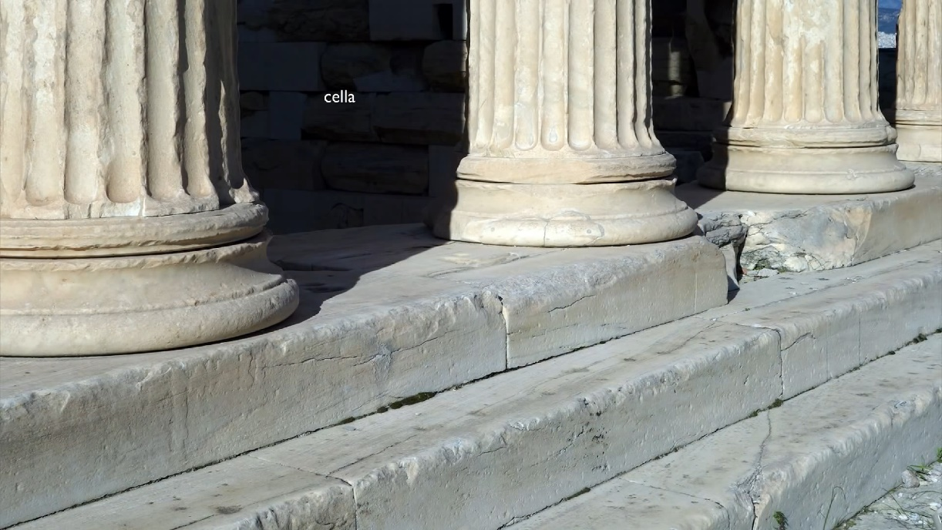Room that is the shrine to the olivewood statue of Athena

**Western Part**

* Dedicated to local hero Boutes, Hephaistos and other gods and heroes
* West side was the location of the original olive tree offered by Athena
* West Side View:
  + Half/ engaged columns in the middle (create symmetry with the east side)

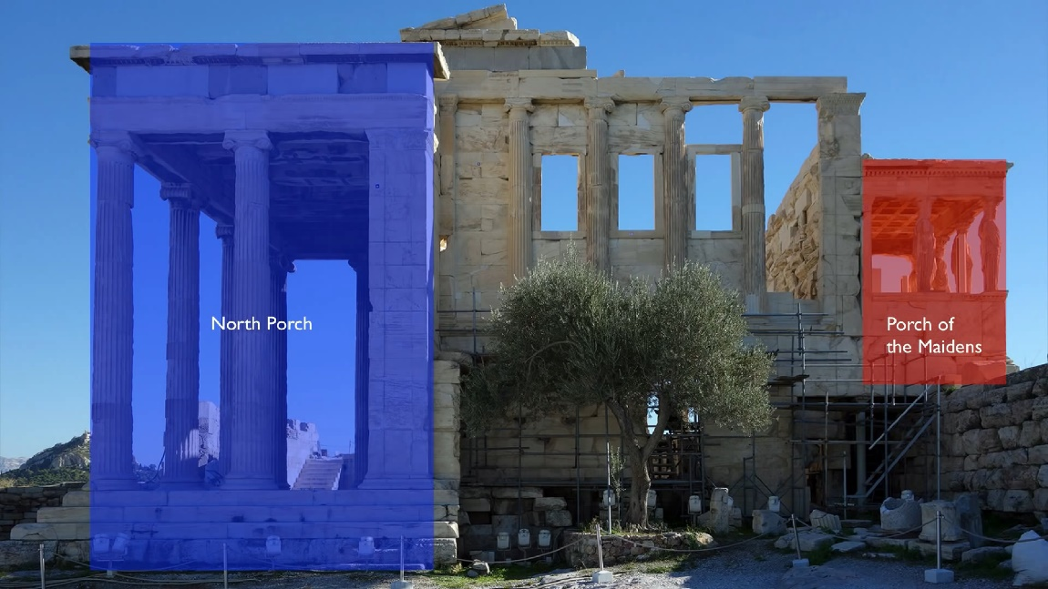

**2 Porches**

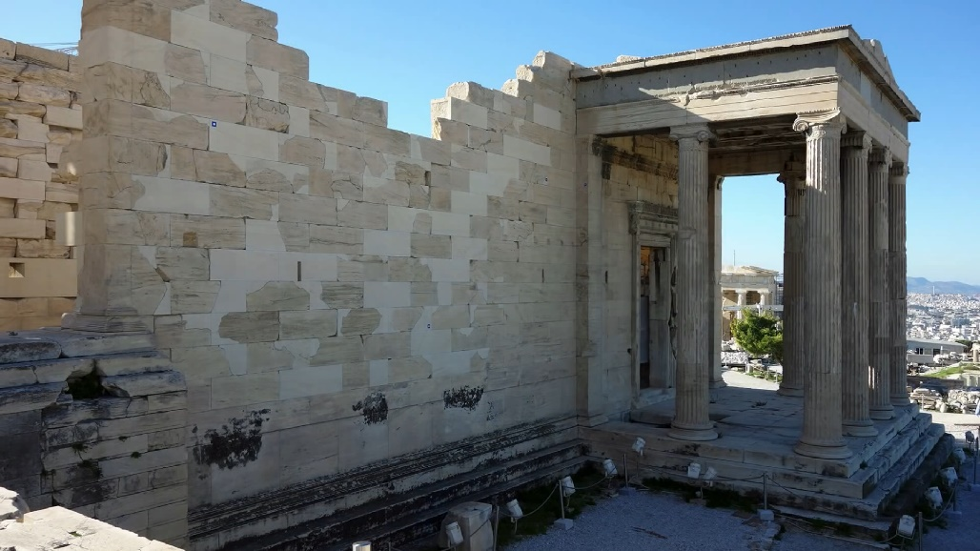**North Porch**

* Stairs that lead to the north porch
* Originally a set of wide stairs

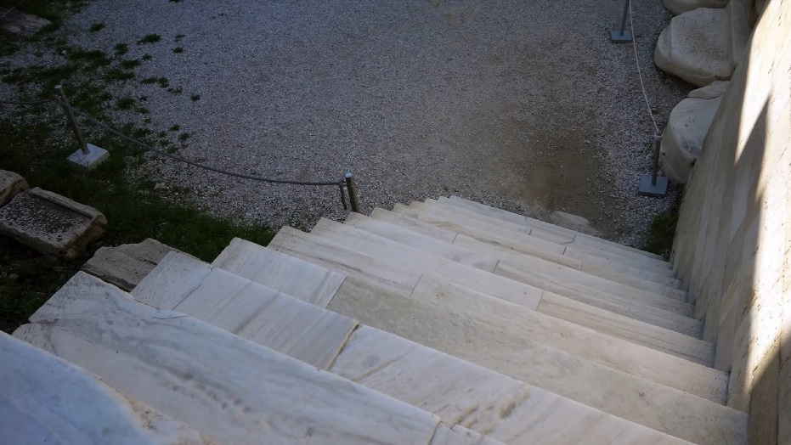

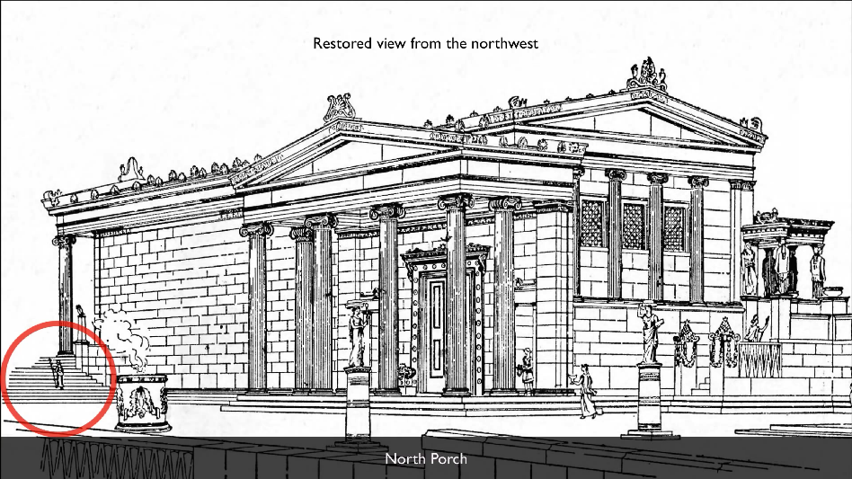

* Stairs led down to area dedicated to Zeus
* Supported by 6 columns
* Hole in the roof where Poseidon’s trident came through and stuck the bedrock (where the spring of saltwater came from)
  + 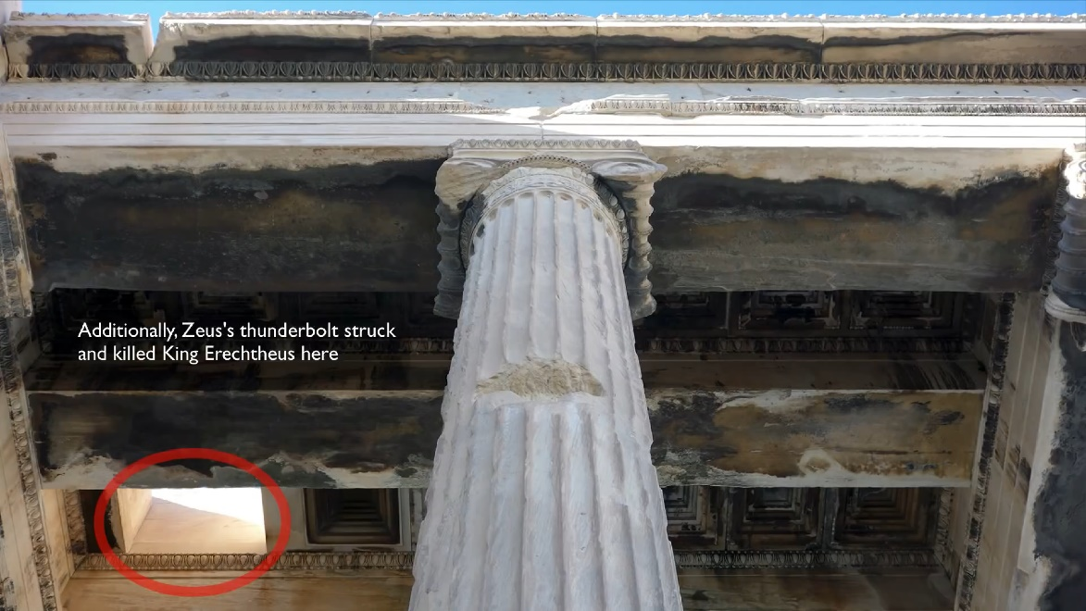Also where Zeus’s thunderbolt struck and killed King Erechtheus
* Missing stone on the floor lets you see the mark on the bedrock beneath

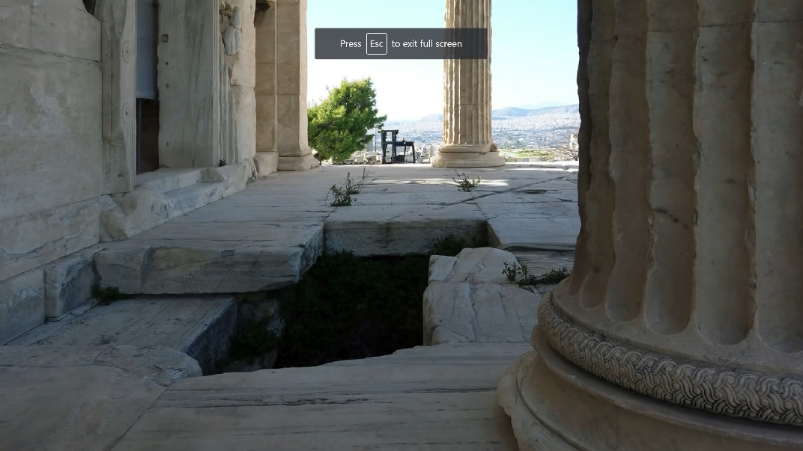

* 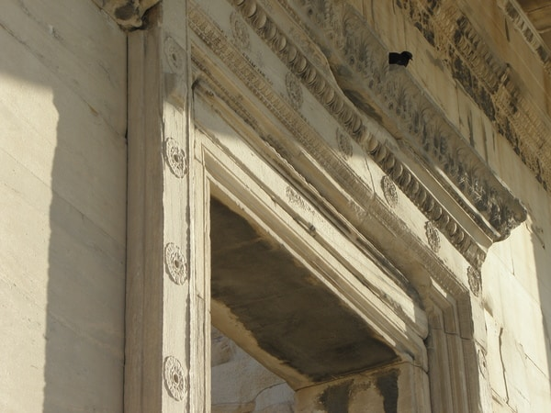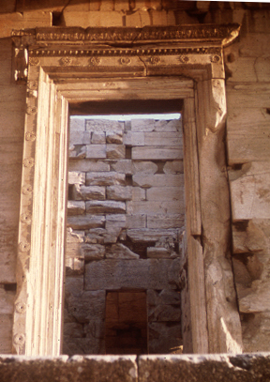Doorway
* Blue marble friese used in original architecture
* Sculpture in pentelic marble (white/ cream color)

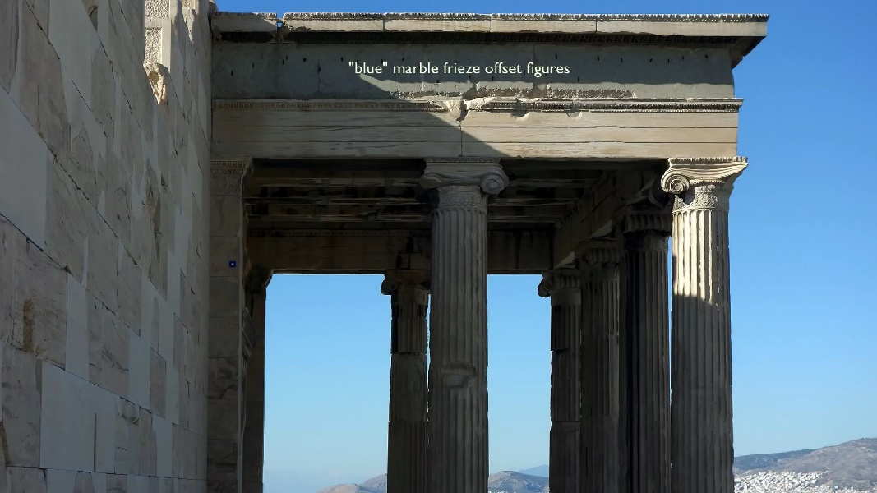

* Detailed entablature high up
* 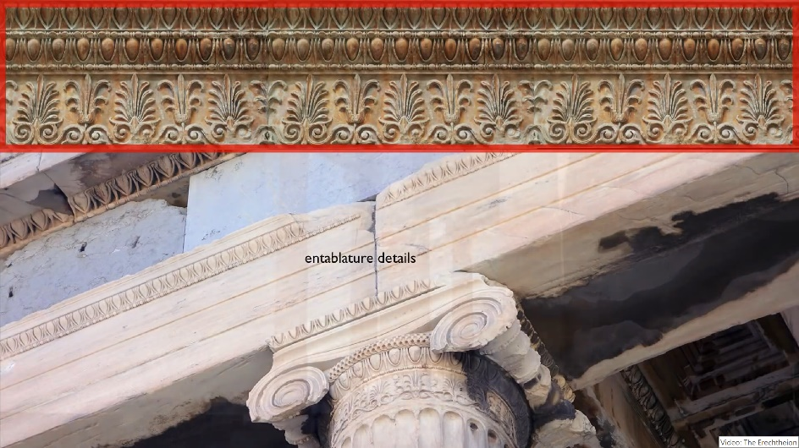Created continuity around the building

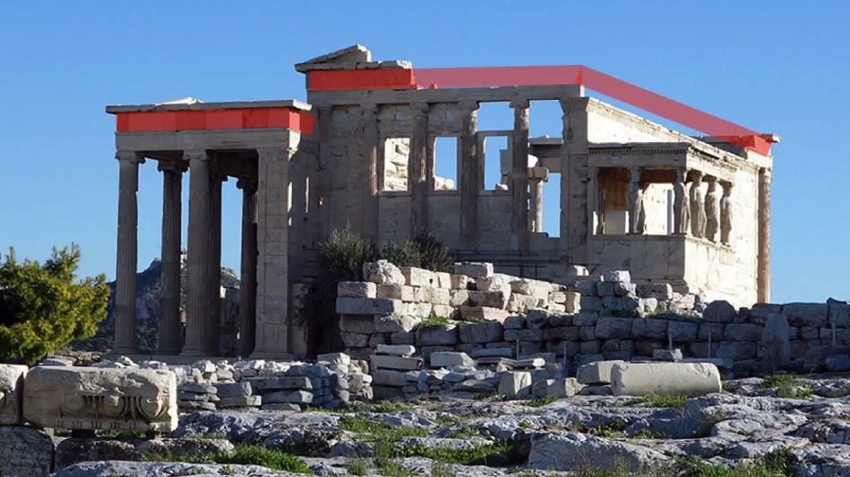

**South Porch (Porch of the Caryatids/ Maidens)**

* Supported by the 6 Caryatids
* Above the grave of Kekrops (Legendary King of Athens)
  + Caryatids are the visible portion of the grave of Kekcrops and they are the choephoroi who paid tribute to the dead
* Built to conceal the giant 15-ft beam needed to support the southwest corner over the Kekropion (grave of Kekrops)
* Inscription refers to the Caryatids as Korai (maidens)
* Caryatids each have 1 locked leg and one bent/ showing movement
  + Stands in contrapposto
  + Locked legs toward the outside to show stability

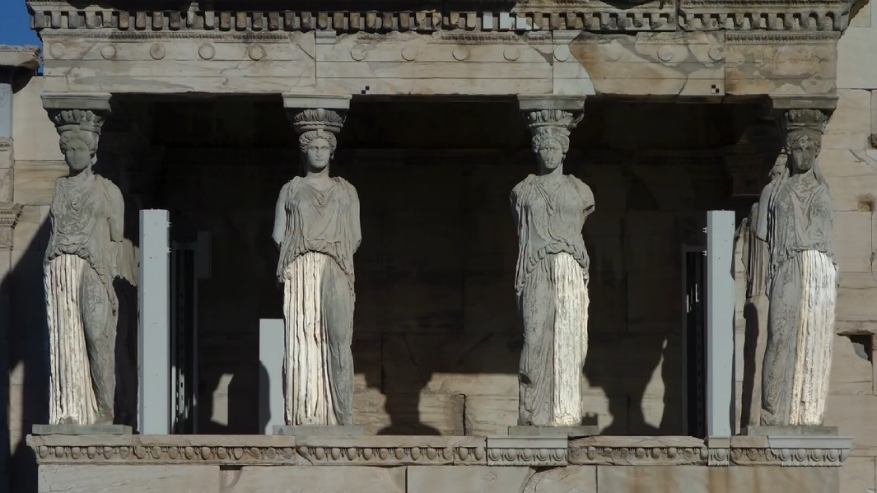

* Wearing heavy weighted garment, pinned at the shoulder

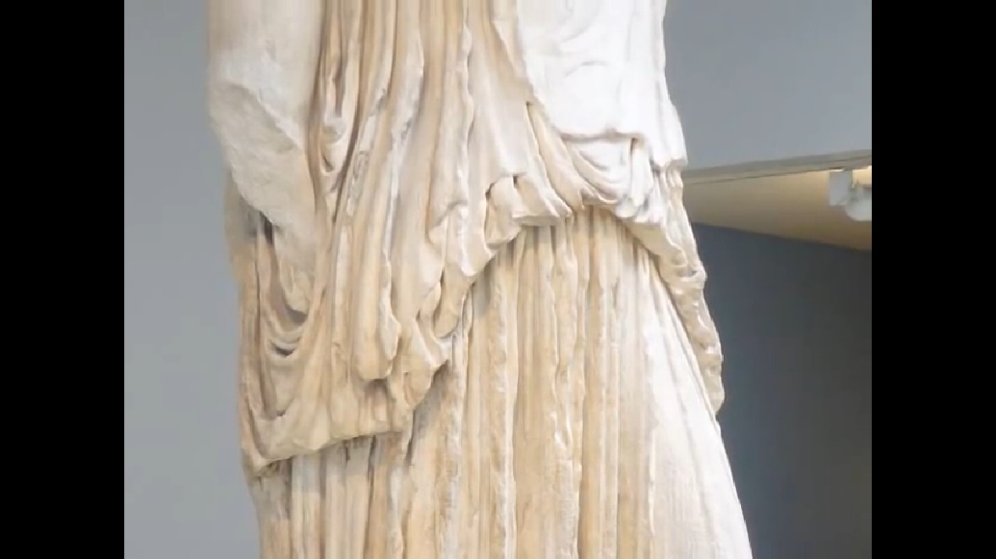

* Hair knotted at the back of the neck to provide extra stability

Dimensions

North Porch

* Length 10.72 m
* Axial spacing exterior columns: 3.09 m (3.15 m corners, 3.067 m flanks)
* Lower diameter exterior columns: 0.817 m (0.824 m corners)
* Height exterior columns: 7.64 m
* Height entablature: 1.68 m
* Floor of the northern porch: 3.24 meters lower than that of the eastern section of the building

East Porch

* Length, 11.63 m
* Axial spacing exterior columns: 2.11 m
* Lower diameter exterior columns: 0.60 m
* Height exterior columns: 6.59 m
* Height entablatures: 1.54 m front, 1.51 m flanks

West Front

* Axial spacing exterior columns: 1.97 m
* Lower diameter exterior columns: 0.62 m
* Height exterior columns: 5.61 m
* Height entablature: 1.54 m

Dates

* Building was begun: 421 B.C.
* Building was completed: 406 B.C.
* Western cella was altered and repaired to include cross walls: 377/76 B.C., and 27 B.C.
* Converted to a Christian church: 7th century A.D.

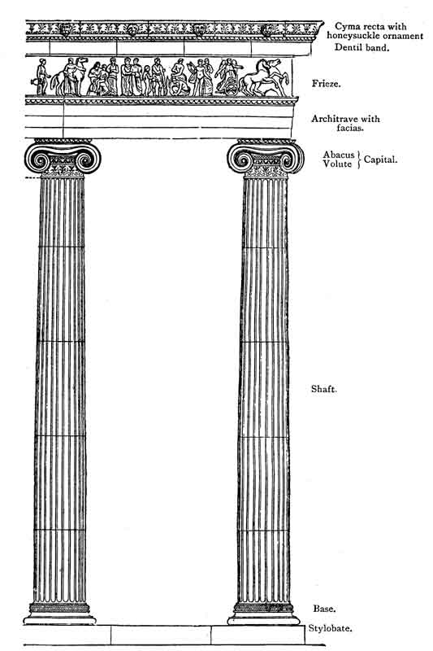Reconstruction Images

